ADVENTURE WORKS · TECHNICAL SUPPORT

Brakes Feel Spongy or Weak
Brakes Document TS-001 Rev. A
Applies to | Trailblazer MTB, Summit Trail, City Cruiser, Velocity Road, PowerRide e-Bike
Difficulty | Beginner – Intermediate
Time required | 20 – 40 minutes
Tools needed | 2.5 / 4 / 5 mm hex keys, Torque wrench, Clean rag & isopropyl alcohol, Bleed kit (hydraulic only)

Symptoms
- Brake lever pulls most of the way to the handlebar before the bike slows.
- The bike takes noticeably longer to stop than when new.
- Lever feels soft, 'mushy', or springy rather than firm.
- Braking power fades on long descents.
- Lever slowly sinks to the bar when held under steady pressure (hydraulic).
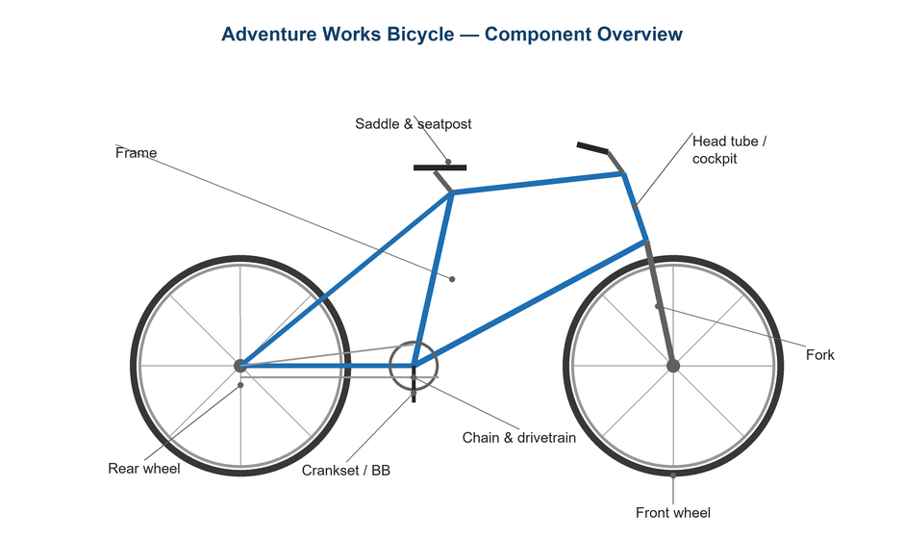
Figure 1. Brake systems are located at the front fork and rear seat-stay.

Likely Causes
- Worn brake pads that have passed their wear line.
- Cable stretch or housing compression on mechanical (cable-pull) brakes.
- Air trapped in the hydraulic line, usually after transport or a pad change.
- Contaminated pads or braking surface (oil, chain lube, or road grime).
- Glazed pad surface from prolonged light dragging.
Safety first
- Brakes are a critical safety system. Do not ride the bike until braking is firm and reliable.
- Never let brake fluid, oil, or chain lube touch the pads or rotor/rim — it permanently reduces stopping power.
- Test the brakes at walking pace in a safe, traffic-free area before any real ride.

Customer Fix — Step by Step
Suitable for home repair with basic tools. Work through the steps in order.
- Squeeze each lever firmly. A good brake stops firm with about 2–3 cm of lever travel and does not reach the bar.
- Inspect the pads. Rim pads should show grooves; replace at 1 mm of pad material. Disc pads should have at least 1 mm of pad above the metal backing.
- For rim brakes, check pad-to-rim gap: pads should sit 1–2 mm from the braking surface and contact the rim squarely, not the tire.
- Wipe the rim or rotor with a clean rag and isopropyl alcohol to remove grime; let it dry fully.
- On mechanical brakes, turn the barrel adjuster (where the cable enters the lever or caliper) counter-clockwise to take up cable slack until the lever firms up.
- Re-test at walking pace. If the lever still feels soft on a hydraulic brake, the system likely needs bleeding (technician step).

Technician Reference
Additional checks and adjustments for service technicians and advanced users.
- Measure pad thickness with a caliper; replace any pad below 1 mm of friction material and bed in new pads with 20–30 progressive stops.
- On mechanical disc/rim brakes, set the pad gap, then re-tension the cable: loosen the pinch bolt, pull the cable taut with pliers, and re-torque the pinch bolt to spec.
- Center the caliper over the rotor: loosen the two mount bolts, squeeze the lever to self-align, then re-torque while holding the lever.
- If the lever sinks under sustained pressure, bleed the hydraulic system per the manufacturer's procedure using the correct fluid (mineral oil vs. DOT — never mix).
- Inspect for fluid weeping at hose fittings and the lever/caliper seals; replace any leaking part before returning the bike to service.
- Confirm rotor is true (≤0.2 mm lateral runout) and free of contamination; replace glazed or oil-soaked pads rather than cleaning.

Torque & Specifications
Fastener / setting | Specification
Disc caliper mount bolts | 6 – 8 N·m
Cable pinch bolt | 5 – 7 N·m
Rim brake mount nut | 8 – 10 N·m
Pad-to-rim clearance | 1 – 2 mm each side
Minimum pad material | 1 mm
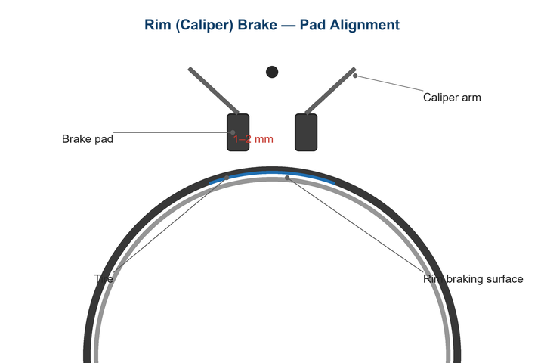
Figure 2. Rim-brake pads should sit 1–2 mm from the braking surface and strike the rim squarely.
Pro tips
- Bed in new pads before your first ride: accelerate to a moderate speed and brake firmly (without skidding) 20–30 times.
- Keep a dedicated rag for brakes so it never picks up chain lube.

When to Visit a Service Center
- Hydraulic lever still feels soft after a full bleed.
- Visible fluid leaking from a hose, lever, or caliper.
- Rotor is bent, cracked, or worn below the minimum-thickness marking.
- You do not have the correct bleed kit or fluid for your brake model.
This guide is provided for reference. Torque values are typical starting points — always follow the specific component manufacturer's instructions. © Adventure Works.

